**Class Diagram For 5 Applications**

**1.Hotel Management system**

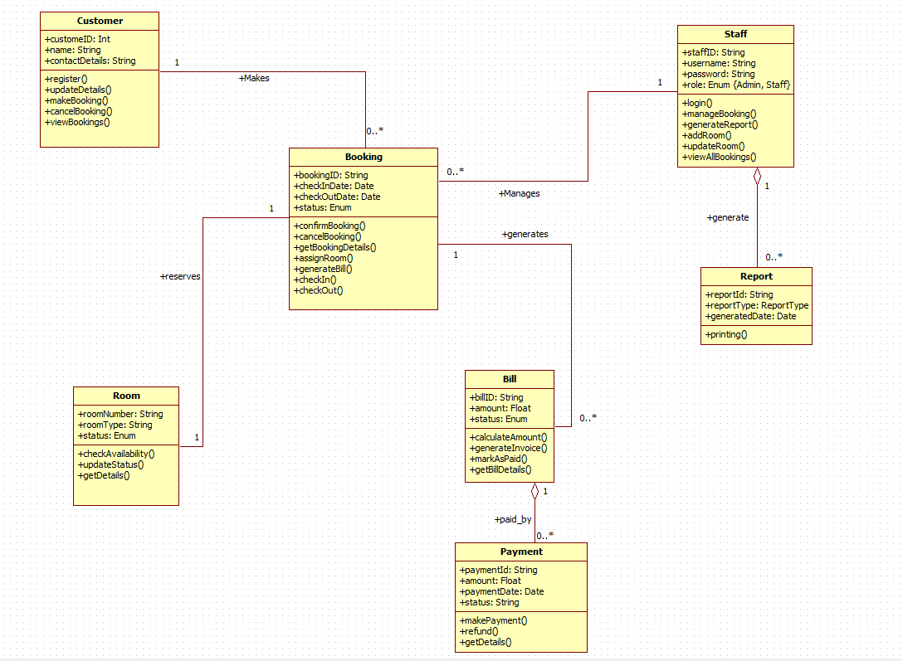

**2.Credit Card Processing**

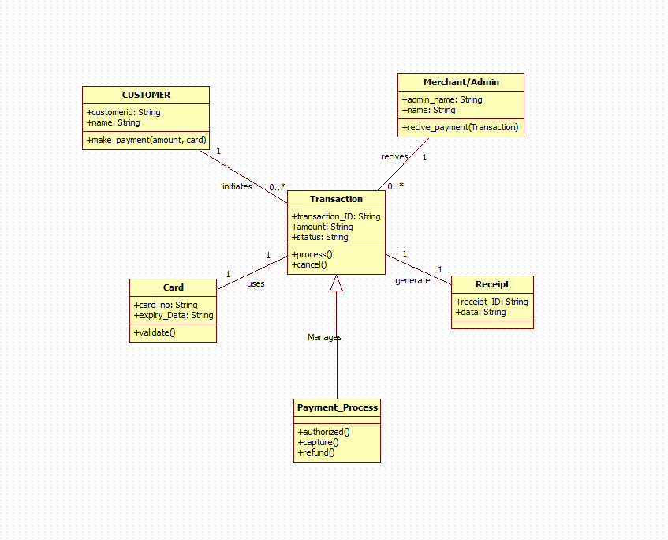

**4.Stock Maintenance System**

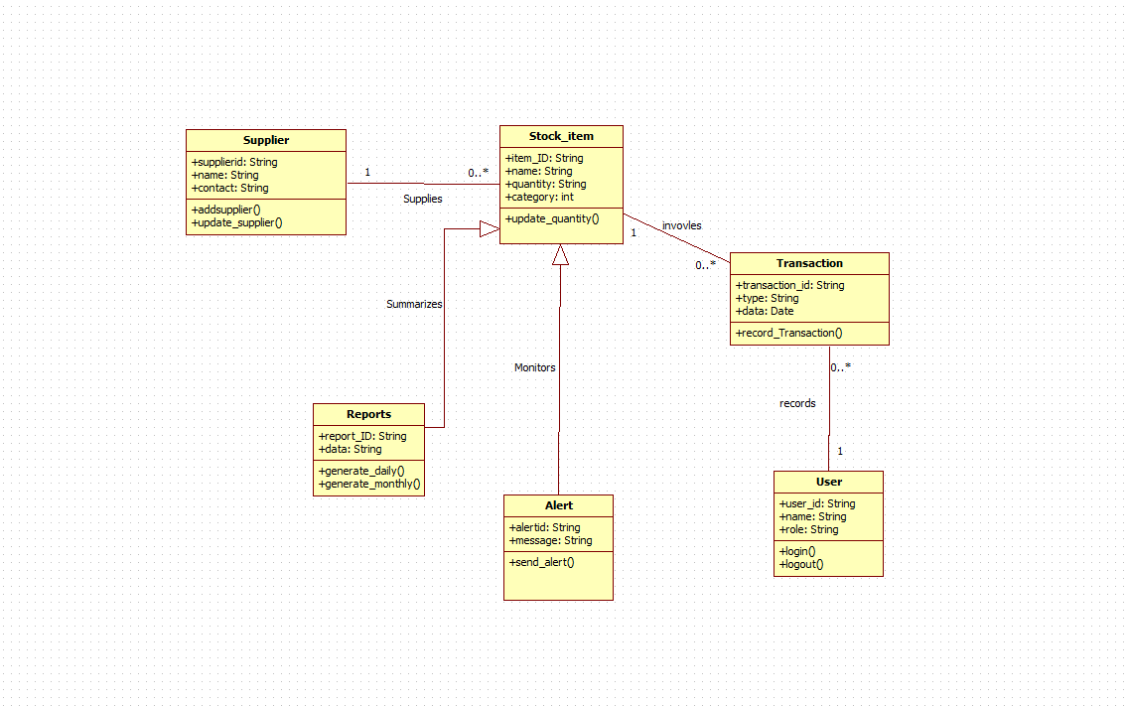

**5.Passport Automation System**

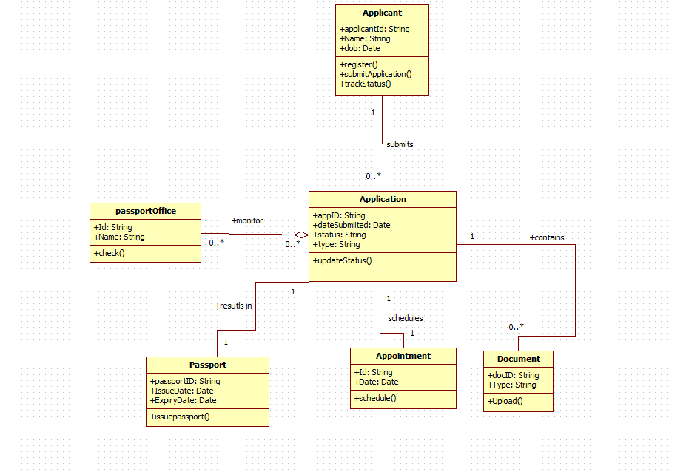

**3.Library Management System**